Non-Profit Discussion
I am currently in discussions with several organizations that have transitioned to 501c3 to better understand the process and the challenges. I’m getting good insight from these conversations so far. I am also starting to gather resources on filing information, legal requirements, etc.
The questions below were asked by Tracy Beckman via email on November 19th.
- Please provide a list of services provided by Dickinson County along with your plan for handling those items, and who the staff will be that is qualified to handle those items if WRISC becomes a stand-alone entity. Specifically, who has payroll experience, including quarterly payroll taxes, W2 preparation, 990 preparations, etc? Who has experience applying for a 501c3 and what is the cost now?
- Review Master Agreement
- Financials/Accounting/Bookkeeping; yearly audit; insurance; overhead*
*Typically 10% indirect on all project funds, Admin wages included as line item in budget, sometimes Accountant wages line itemed as well (in addition to Indirect)
Options:
1. Conduct financial management in-house. Lindsay has some experience
2. Contract out financial management – seek local accountant with non-profit experience
- Comparison of different accounting software services – report pending
- No current staff with 501c3 experience.

- Current filing cost estimates are included below:
- MICHIGAN:
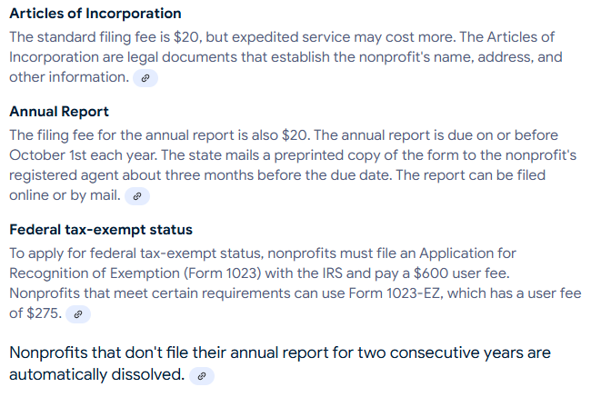

- WISCONSIN


- A list of pros and cons (Coordinator perspective):
Primary motivation for pursuing NP status: Accounting stability and financial capacity
PROS:
- Could eliminate consistent issues/challenges with accounting errors, improper reporting, bookkeeping inaccuracies.
- Allow WRISC to fundraise and accept donations
- Could add to the versatility of the organization, not limited by an additional Board and organizational structure
- May allow WRISC to increase capacity, both in physical space and in operations
- Could overcome cash flow challenges
- Opens up more opportunities for WRISC – partnerships, grants, fundraising, project initiatives, etc.

CONS:

- Need to manage financials – in-house, contractual, other
- Space/Building – may need to find new office space
- Truck – would need to lease/purchase a vehicle for WRISC crews; or work out temporary agreement for truck use
- Could encounter cash-flow challenges – will need to operate projects on advances and fundraising as a safety net, will take time and careful planning
- Could damage partnership with DCD – this is a significant financial blow to their organization
- Will take a considerable amount of time and effort – loss of job/life balance for Coordinator

- Where will WRISC's office be located and what is the cost?
- WRISC is able to remain at the current building as long as we start paying a portion of rent ($50/month). USDA NRCS rents the entire building and pays for utilities, but DCD currently pays a small rent portion to legally be considered a tenant. WRISC would do the same. Also any utilities costs over the USDA baseline are DCD responsibilities.
- However, it is likely that when Tom, our NRCS District Conservationist retires (~2-5 years est.), USDA NRCS will audit the office space upon looking to fill the vacancy and it is highly unlikely that they will continue to pay rent for then entire building, which will result in increased rent.
- Additionally, WRISC has run out of room at this current space, both for people and equipment. It is recommended that WRISC explore building options for the near future, preferably something with a garage space for equipment storage.

